2020 LION OF JUDAH FAST
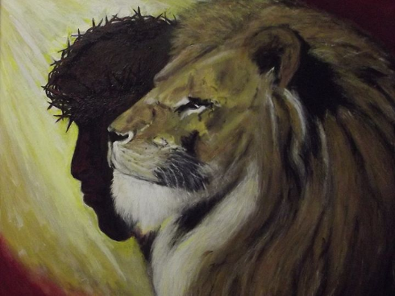

Focus: Courage, Hope & Faith – The focus is to combat spiritual fatigue which can lead to cowardice, despair and fear. When times get dark and tough only the courageous, hopeful and faithful can be counted upon to rise up and illuminate this darkened world with the piercing bright light of their good words and deeds.
Duration: 24 hours and 21 days (3 weeks)
Permissions: You can add to your fast, but you are directed not to take away from the Lion of Judah Fast.
- Instructions: Each week is progressive. Weeks 2 and 3 add and build onto week 1. Each day we want you to start a conversation with a different person outside your household to share your thoughts about the daily scripture, and or whatever Gods places in your heart.
- Week # 1 – no bread or bread products, sweets, deserts or processed foods (foods of more than 3 ingredients), i.e., crackers, corn chips, pasta, cakes, cookies, noodles, hot pockets, pringles or protein bars. Canned meat is not included and is allowed.
- Week #2 – no carbonated or alcoholic beverages
- Week #3 – Liquids only, smoothies and protein drinks, are allowed.
Focal Scriptures: Ezra 8:21, 2 Chronicles 20:3, Isaiah 58:6-14 (NLT)
Daily Scriptures:
1 - 2 Timothy 1:7 > fear/courage
2 - 1 Corinthians 15:19 > hope
3 - Galatians 2:20 > faith
4 - 1 Timothy 6:12 > faith
5 - Psalms 21:1 > fear
6 - Proverbs 13:12 > hope
7 - Revelation 2:10 > fear
8 - Philippians 1:20-21 > hope
9 - Deuteronomy 31:6 > fear, courage
10 - Joshua 1:9 > courageous
11 - 2 Samuel 10:12 > courage (NLT)
12 - Proverbs 24:14 > hope
13 - Titus 3:7 > hope
14 - Deuteronomy 31:23 > courage (NLT)
15 - Hebrews 6:11 > hope
16 - Jude 1:20 > faith
17 - 1 Peter 3:15, hope
18 - Deuteronomy 7:9 > faith
19 – 2 Thessalonians 1:3 > faith
20 - 2 Peter 1:5 > faith
21 - 1 Timothy 4:12 > faith

